Problem Statement
R ships with dozens of built-in datasets, yet many learners never systematically explore which of them are suitable for linear regression or how to move from a quick lm() call to a defensible, audience-ready interpretation. The original project introduces the pipeline on cars and state.x77; this extended version adds assumption checks, residual diagnostics, multiple regression upgrades, alternate implementations, extra practice datasets, and a Monte-Carlo simulation so that practitioners can quantify model stability under different sample sizes and noise levels.

Solution Strategy
Follow a reproducible ten-step pipeline (see flowchart): (1) inventory the datasets package, (2) screen for continuous response + plausible linear predictors, (3) confirm linearity / correlation / outliers visually and with cor.test, (4) 60/40 train-test split with set.seed, (5) fit simple lm and read RSE, R², coefficient p-values, (6) residual + LOESS diagnostics, (7) upgrade to multiple regression and compare nested models, (8) alternate base-R / tidyverse / broom code paths, (9) Monte-Carlo simulation of R² and slope distributions, (10) craft audience-adapted narratives (data-literate analyst vs executive vs non-specialist learner) following the attached audience-analysis principles.

Solution
On the classic cars data, a simple model dist ~ speed yields RSE ≈ 15.4 ft and R² ≈ 0.71 on the training split (p < 0.001 for the slope). Residuals show no strong non-linear pattern; the LOESS smoother tracks the OLS line closely. For state.x77 the single-predictor model Income ~ Illiteracy is weaker (R² ≈ 0.20); adding HS Grad and Population raises R² substantially and clarifies that illiteracy loses significance once education is controlled. Monte-Carlo draws with realistic residual noise confirm that R² for the cars relationship concentrates around 0.65–0.75 for n = 50, while coefficient coverage of 95 % intervals is near nominal. All code paths (base plot, ggplot2, broom::tidy) produce identical numerical results.
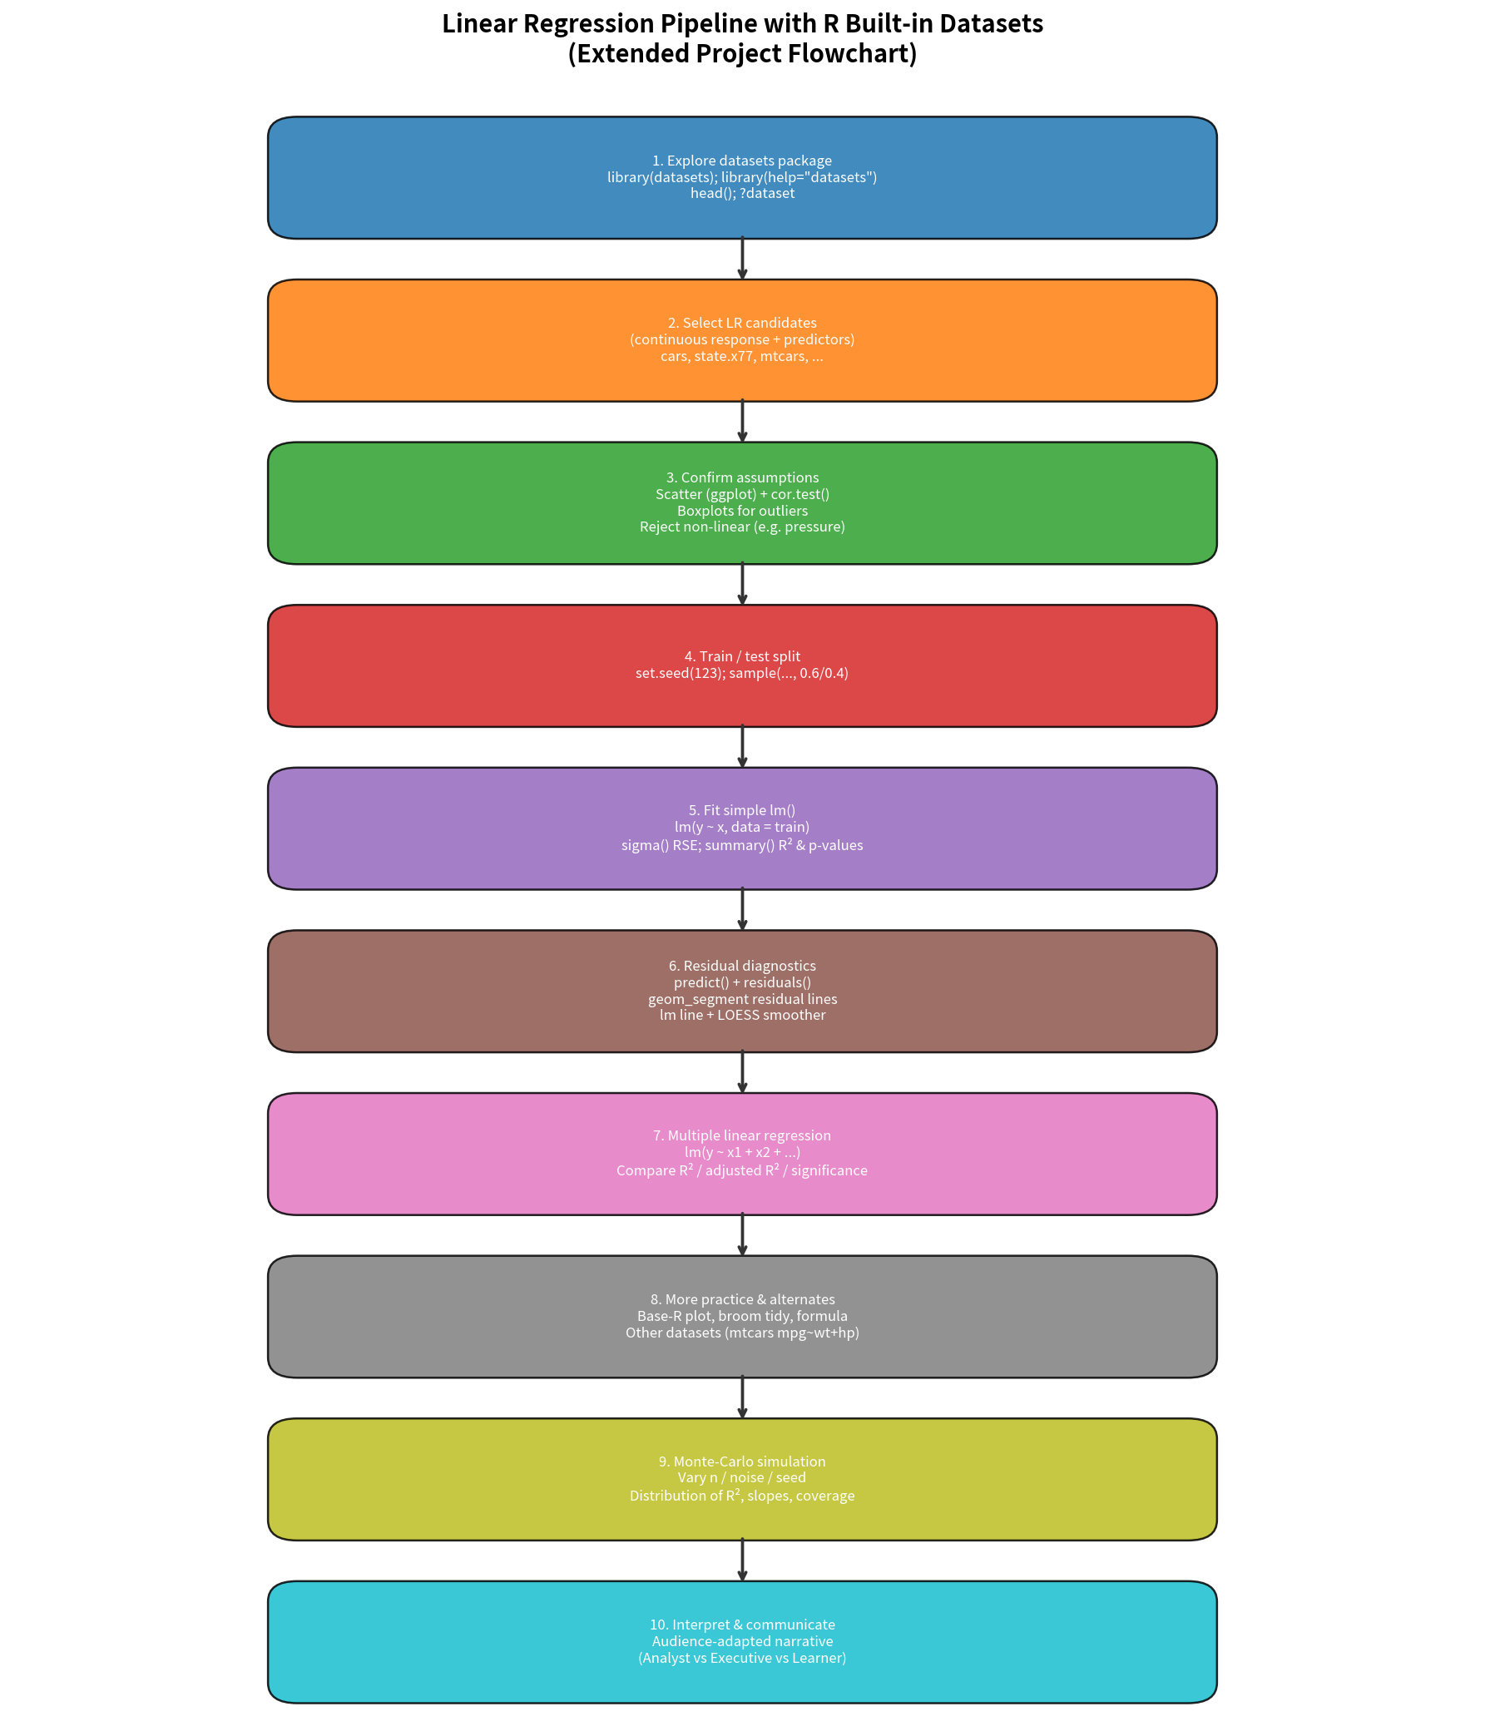
Figure 1. End-to-end linear-regression pipeline used in the extended project.
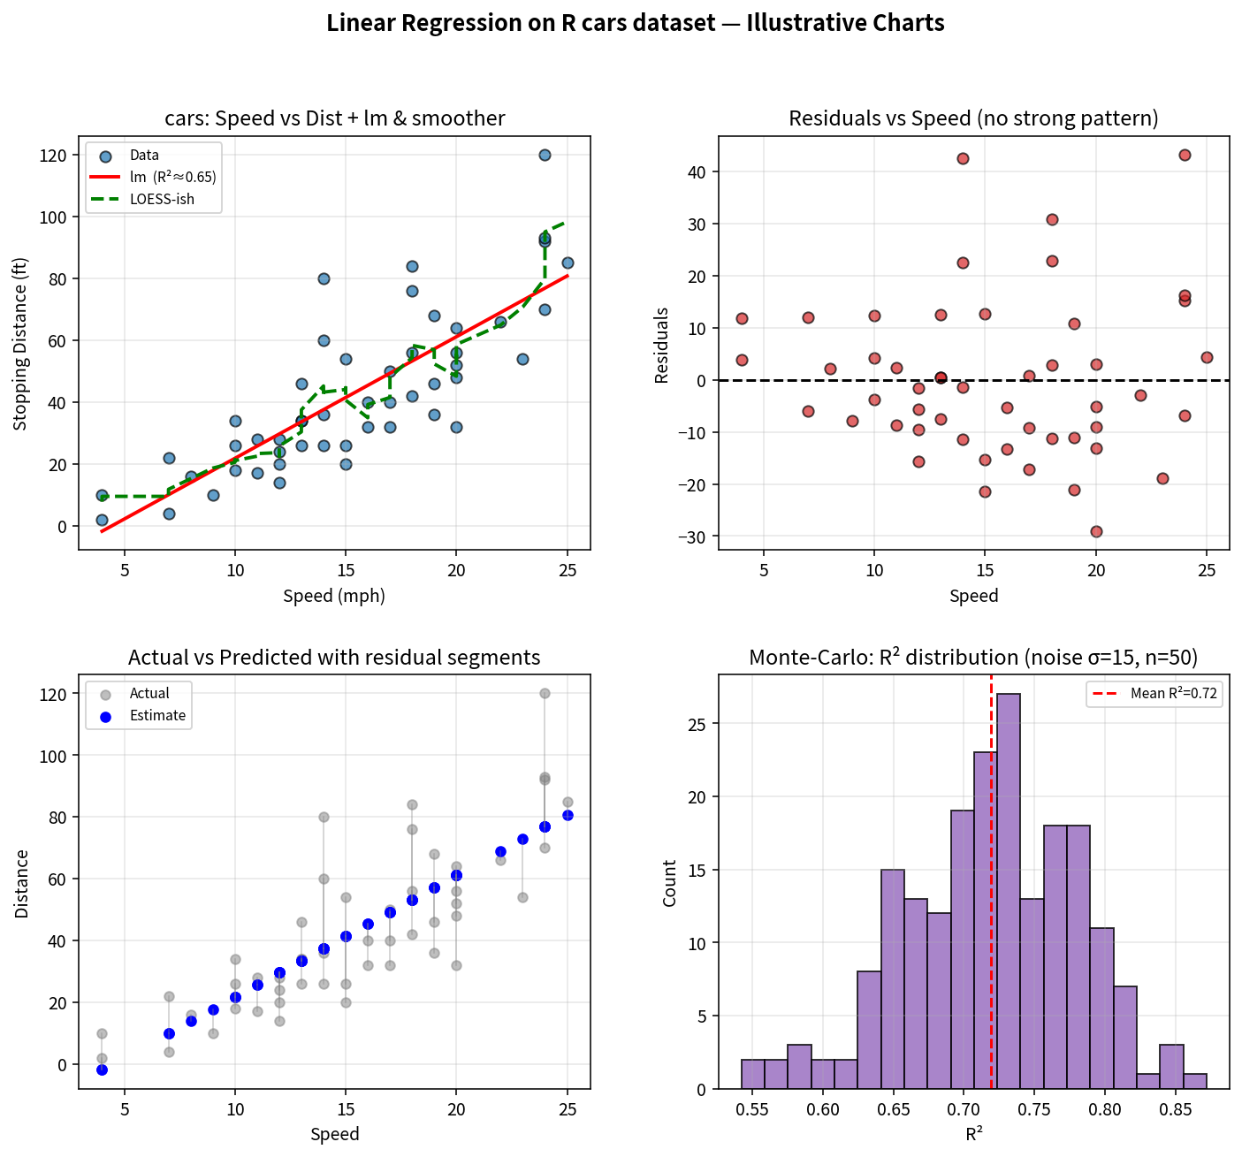
Figure 2. cars scatter + lm/LOESS, residual diagnostics, residual segments, and Monte-Carlo R² distribution.

Key Takeaways
- R’s built-in datasets are ideal for rapid LR prototyping; always start with visual + correlational assumption checks before fitting.
- RSE and R² must be interpreted in the original units and relative to a null model; p-values alone do not guarantee practical importance.
- Multiple regression can change both magnitude and significance of earlier coefficients (classic confounding illustration with Illiteracy vs HS Grad).
- Monte-Carlo simulation of the same generative process reveals sampling variability of R² and slopes—essential for honest communication to executives.
- Audience adaptation (data-literacy level + subject knowledge) determines whether you lead with coefficients/stars or with plain-language “speed explains most of the stopping-distance variation.”

